COMMUNITY COLLEGE OF PHILADELPHIA
Proficiency Certificate Template

Name of Proficiency Certificate | Project Management
Academic Pathway | Business, Entrepreneurship, & Law
Department | Business Leadership, Fashion, and Hospitality
Faculty Developer | Dr. Lynsey Madison
Facilitator | Amy Birge-Caracappa
New or Revised? | New
If this is a revision, indicate which are being revised (check box) | ☐Title of PC | ☐Catalog Copy | ☐Program Sequence/Grid
 | ☐PLOs | ☐Curriculum Map | ☐Credit Hours: ___ to ___
Recommended Starting Semester | Fall 2021
Today’s Date | February 24, 2021

Part 1: Rationale

According to a 2017-2027 talent gap analysis completed by Project Management Institute (PMI), there continues to be a widening gap between employers’ need for skilled project managers and the number of skilled professionals able to fill the positions (Project Management Job Growth and Talent Gap Report, 2017). This gap continues to widen for several reasons: a dramatic increase in the number of jobs requiring project-oriented skills, an aging workforce that accelerates the attrition rate through retirement, and an uptick in demand for project talent. Emsi data shows both aggressive job posting demand and higher than average compensation in the region (see Appendix). These factors highlight the role project managers serve in driving change and innovation in their respective organizations.

Not only do project managers drive change and innovation, but they also contribute to the GDP. The talent gap for project managers, “could result in a potential loss of $207.9 billion USD through 2027 for the eleven countries analyzed” and $22.5 billion in the United States (Project Management Job Growth and Talent Gap Report, 2017). As the global economy becomes more project-oriented, the practice of project management has expanded into industries that have been historically less project-oriented, e.g., health care, publishing, and technology. Job openings for approximately 8.8 million jobs are expected across a multitude of sectors by 2027, including manufacturing and construction, information services and publishing, finance and insurance, management and professional services, utilities, and oil and gas (Project Management Job Growth and Talent Gap Report, 2017).

As demand for practitioners with the necessary mix of competencies grows, there is a correlating need for educational programs to provide training in project management that instills and reinforces the skills that students need in order to perform in the workplace. These skills include communication, problem-solving, leadership, management, and customer service, all of which students learn in the Project Management PC (see Appendix). Project management crosses various disciplines, and thus this proficiency certificate will enable current and returning students to gain the skills to grow their career in their chosen field.

Studies show that certificate programs not only prepare students for an opportunity to gain a new skill, but also can motivate students to continue in higher education. According to the Department of Bureau and Labor Statistics, students earning a certificate as their highest level of education earn on average twenty percent more than those with only a high school diploma (BLS 2013). Students increase their earnings by thirty-one percent with an associate’s degree. The proficiency certificate is designed to fit into the Business Leadership A.A.S. With the increased job opportunities in fields like health care, technology, and construction within the city of Philadelphia (see Appendix), this certificate has the potential to place students in a position to fill the growing job market.

The Project Management proficiency certificate focuses on students interested in advancing their career opportunities through project management. It is also designed to fill the complementary discipline segment of the Business Leadership A.A.S. degree. Students deciding to complete the Business Leadership degree will be able to apply the courses to the degree.

The Project Management advisory committee advised the College in the development and delivery of the Project Management Proficiency Certificate, focusing particularly on how to facilitate student success and meet employer needs. A committee member initially proposed the idea of creating an associate degree as a pipeline for future project management industry professionals, which became the proficiency certificate. The advisory committee provided input on the PC and its relationship to the Business Leadership AAS, highlighting the importance of career outcomes, technical skills, soft skills and behaviors, and critical thinking. The advisory committee also emphasized that having a project management curriculum at the College will diversify the pool of qualified candidates for careers in project management (See Appendix).

Part 2: Catalog Copy

Project Management Proficiency Certificate

Description: The Project Management Proficiency Certificate prepares students to enter the project management workforce. Students will learn the management principles and theories that put them on the path towards a rewarding project management career in various industries, such as health care, information technology, construction, finance, and advertising. Students gain hands-on experience through various course assignments and requirements. The Project Management Proficiency Certificate offers courses that develop skills in project management, communications, agile project management, and organizational leadership. The courses in the certificate also apply towards the Business Leadership A.A.S. degree.

Upon completion of the certificate, students will be prepared to take the Certified Associate Project Manager (CAPM from the Project Management Institute) exam, providing a competitive and financial advantage in the job market. Graduates of the program are prepared for positions such as IT program support specialist, project manager, emergency response project manager, marketing communications coordinator, and member relations administrator.

Student Learning Outcomes:

Upon successful completion of the Project Management proficiency certificate, students will be able to:
- Describe the importance of project management in the context of various organizational structures and strategies
- Use basic project management planning tools for communications, risk analysis, cost estimation and budgeting, and quality control
- Create and design templates for scheduling, controlling costs, and project completion
- Communicate effectively both orally and in writing and demonstrate effective interpersonal skills in a team setting

Entrance Requirements: This certificate is open to interested students. New students are normally required to take the College’s placement test at their time of entry. Students who are identified as needing developmental course work must satisfactorily complete the appropriate English and mathematics courses as part of the certificate when applicable.

Project Management Proficiency Certificate Course Sequence

Course Number | Course Name | Prerequisite or Corequisite | Credits
PJMT 110 | Foundations of Project Management |  | 3
PJMT 130 | Project Management Communications |  | 3
PJMT 140 | Emerging Trends in Project Management | PJMT 110, which may be taken concurrently | 3
PJMT 220 | Advanced Project Management | PJMT 110 and PJMT 140 | 3
BUSL 215 | Organizational Leadership | BUSL 125 or  PJMT 110 and PJMT 130 | 3
PJMT 240 | Project Management Work Experience | PJMT 220 | 3
Total Credits |  |  | 18

Successful Completion: Successful completion of the program requires a “C” grade or better in each of the courses listed above.

For More Information, Contact: The Division of Business and Technology, Room B2-22, 1700 Spring Garden Street, Philadelphia, PA 19130, Telephone (215) 751-8785; or the College Information Center (215) 751-8010.

Part 3: Curriculum Map

Required Courses | Proficiency Certificate Student Learning Outcomes
 | Describe the importance of project management in the context of various organizational structures and strategies | Use basic project management planning tools for communications, risk analysis, cost estimation and budgeting, and quality control | Create and design templates for scheduling, controlling costs, and project completion | Communicate effectively both orally and in writing and demonstrate effective interpersonal skills in a team setting
PJMT 110 | I, A | I, A | I | I
PJMT 130 |  | R |  | M, A
PJMT 140 | R | R, A | R, A | R
PJMT 220 | M, A | R | R | R, A
BUSL 215 |  |  |  | R
PJMT 240 | M, A | M | M, A | M

Key: I—Introduced R—Reinforced and opportunity to practice
M—Mastery at exit level A—Assessment evidence collected

Part 4: Courses and Completion Sequence

The following courses and sequence of courses is designed for the optimal success and completion of the Project Management degree/certificate. Any alterations should be discussed with your academic advisor.

Course Name and Number | Credits | Advisory Notes
PJMT 110 - Foundations of Project Management | 3 | Prerequisite for PJMT 140, PJMT 220, and BUSL 215
PJMT 130 - Project Management Communications | 3 | Prerequisite for BUSL 215
PJMT 140 - Emerging Trends in Project Management | 3 | Prerequisite for PJMT 220
PJMT 220 - Advanced Project Management | 3 | Prerequisite for PJMT 240
BUSL 215 - Organizational Leadership | 3
PJMT 240 - Project Management Work Experience | 3

Appendix

Project Management Advisory Committee
Minutes
October 16, 2020

In Attendance: Tim Brown (Johnson & Johnson), Pam Carter (CCP), Sonya Dore (Comcast), Peggy Gionta (Partners Consulting), Reggie Haynes (Penn Medicine), Philip Jaurigue (Sabre Systems), Mary Pat Kessler (Project Management Institute), Himalay Khimani (Comcast), John Klein (PMI), Korinna Lark (Comcast), Lynsey Madison (CCP), Sallie Makar (PMI), PaShon Mann (Comcast), Michael Marrone (Liguori Academy), Scott McCreary (Children’s Hospital of Philadelphia), Felicite Moorman (Stratis IoT), Alice Niles (Liguori Academy), Arielle Norment (CCP), Barbara Romano (SJ Industries), Joanne Sibony (Comcast), Peter Slattery (Philabundance)
The meeting began at 10:03 with an overview of the agenda.
- Participants were welcomed and everyone introduced themselves.
  - Advisory Committee Contacts: Dr. Lynsey Madison (lmadison@ccp.edu) Department Head of Business Leadership, Fashion & Hospitality and Dr. Pam Carter (pcarter@ccp.edu) Dean of Business & Technology
  - Key Contributors to CCP Project Management program start -- Korinna Lark developed idea for creating associate degree as pipeline for future project management industry professionals. Korinna brought idea to Mary Pat Kessler, who brought idea to CCP president, Dr. Guy Generals.
- Project Management Advisory Committee
  - Overarching purpose of committee is to advise CCP in the development and ongoing delivery of a Project Management Proficiency Certificate (PMPC) to facilitate student success and meeting employer needs.
  - The committee serves as a means of connecting academic and industry, gain industry expertise input during curriculum development and ongoing program maintenance and continuous improvement.
  - Expectation is committee will meet twice yearly.
  - There will be additional program support opportunities, such as serving on subcommittees or developing financial support for student certification exam fees.
- Project Management Education Strategy
  - The curriculum is in the development stage and students will be able to get their A.A.S in Business Leadership with a concentration in Project Management. The Business Leadership degree is intended for students who want to gain an educational foundation in business while allowing them to specialize in another area, in this case Project Management.
  - The current timeline for the curriculum process is tight. Typically, this process takes more than a year. We are accelerating the process, in part through the use of PMI curriculum elements, so that students can start in the 2021-2022 academic year. This requires approval of the PMPC by the end of February 2021. With a February timeline, we can recruit students in the spring and the summer (when the registration push typically happens).
- AAS Business Leadership with Project Management Concentration
  - Overview of the AAS Business Leadership degree program was provided, which consists of business leadership core courses, general education courses, and the PMPC.
  - Discussion among committee members focused on desired program outcomes and skills. The general outcomes were program related, career, technical skills, soft skills and behaviors, and critical thinking
    - Program related
      - Value proposition as a key foundation of program
      - How do we explain PM & value to someone unfamiliar with the career?
    - Career
      - Job readiness
      - Variety of career options in PM
      - Path to employment
      - Challenges to full-time employment
      - Pre-apprenticeship program
      - Preparation to find a job once they have content
    - Technical skills
      - Microsoft Office
      - Note taking
      - Task Management (a few times)
      - Software development lifecycle
      - Tactical and ancillary skills
    - Soft skills and Behaviors
      - Relationship building
      - Resiliency
      - Growth mindset
      - Adapt to organization pace/needs
    - Critical thinking
      - Framework to approach problem
      - Case studies with real world problems using solutions that apply course skill set
      - Difference between achieving business outcomes and completing tasks
- Next steps
  - Follow-up emails regarding advisory committee commitment, PMPC program draft will be sent.
  - Create shared repository to facilitate information sharing and document access.
  - Determine subcommittees members expressed an interest in developing.
  - Next full committee meeting tentatively scheduled for January 2021.
  - Committee members are free to contact Lynsey Madison (lmadison@ccp.edu) or Pam Carter (pcarter@ccp.edu) with any follow-up questions, comments, or ideas.
The meeting concluded at 11:08.

Excerpt from the Emsi Occupation Overview
Project Management Specialists and Business Operations Specialists, All Other
in Philadelphia-Camden- Wilmington, PA-NJ-DE-MD

Project Management Specialists and Business Operations Specialists, All Other (SOC 13-1198):
Analyze and coordinate the schedule, timeline, procurement, staffing, and budget of a product or service on a per project basis. Lead and guide the work of technical staff. May serve as a point of contact for the client or customer. Excludes Management Occupations (11-0000), Logisticians (13-1081), Meeting, Convention, and Event Planners (13-1121), and Production, Planning, and Expediting Clerks (43-5061). All business operations specialists not listed separately.

Report Parameters

1 Occupation
13-1198 Project Management Specialists and Business…

1 MSA
37980 Philadelphia-Camden-Wilmington, PA-NJ-DE-M…

Class of Worker
QCEW Employees

The information in this report pertains to the chosen occupation and geographical area.

Executive Summary

Aggressive Job Posting Demand Over a Thin Supply of Regional Jobs
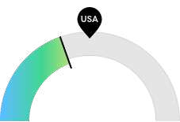
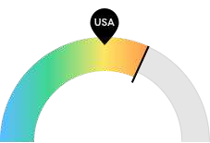
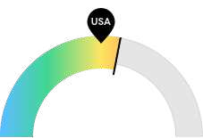

12,961

$81,737

441

Jobs (2015)

Compensation

Job Posting Demand

Philadelphia-Camden- Wilmington, PA-NJ-DE-MD is not a hotspot for this kind of job. The national average for an area this size is 18,040* employees, while there are 12,961 here.
Earnings are high in Philadelphia-Camden- Wilmington, PA-NJ-DE-MD. The national median salary for Project Management Specialists and Business Operations Specialists, All Other is $73,570, compared to
$81,737 here.
Job posting activity is high in Philadelphia-Camden- Wilmington, PA-NJ-DE-MD. The national average for an area this size is 372* job postings/mo, while there are 441 here.

*National average values are derived by taking the national value for Project Management Specialists and Business Operations Specialists, All Other and scaling it down to account for the difference in overall workforce size between the nation and Philadelphia-Camden-Wilmington, PA-NJ-DE-MD. In other words, the values represent the national average adjusted for region size.

Jobs

Regional Employment Is Lower Than the National Average

An average area of this size typically has 18,040* jobs, while there are 12,961 here. This lower than average supply of jobs may make it more difficult for workers in this field to find employment in your area.
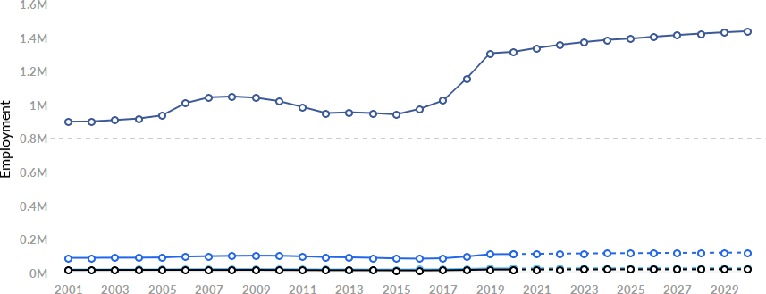

Region | 2015 Jobs | 2025 Jobs | Change | % Change
Philadelphia-Camden-  - Wilmington, PA-NJ-DE- | 12,961 | 18,812 | 5,851 | 45.1%
MD
- National Average | 18,040 | 26,150 | 8,109 | 44.9%
- 4 States | 84,012 | 115,433 | 31,421 | 37.4%
- United States | 940,839 | 1,391,651 | 450,812 | 47.9%

*National average values are derived by taking the national value for Project Management Specialists and Business Operations Specialists, All Other and scaling it down to account for the difference in overall workforce size between the nation and Philadelphia-Camden-Wilmington, PA-NJ-DE-MD. In other words, the values represent the national average adjusted for region size.

Regional Breakdown

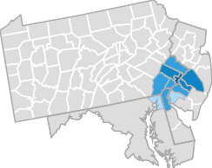
County | 2015 Jobs
Philadelphia County, PA | 3,255
Burlington County, NJ | 2,169
Montgomery County, PA | 1,663
Camden County, NJ | 1,515
New Castle County, DE | 1,153

Most Jobs are Found in the Federal Government, Civilian Industry Sector

Industry
% of Occupation in Industry (2015)

⬤ Federal Government, Civilian 15.7%

⬤ Management of Companies and 8.2% Enterprises

⬤ Management, Scientific, and Technical 4.8% Consulting Services

Local Government, Excluding Education
⬤
 | and Hospitals
⬤ | General Medical and Surgical Hospitals | 3.0%
⬤ | Insurance Carriers | 2.9%
⬤ | Other | 61.8%

3.5%

Compensation

Regional Compensation Is 11% Higher Than National Compensation

For Project Management Specialists and Business Operations Specialists, All Other, the 2019 median wage in Philadelphia-Camden-Wilmington, PA-NJ-DE-MD is $81,737, while the national median wage is $73,570.
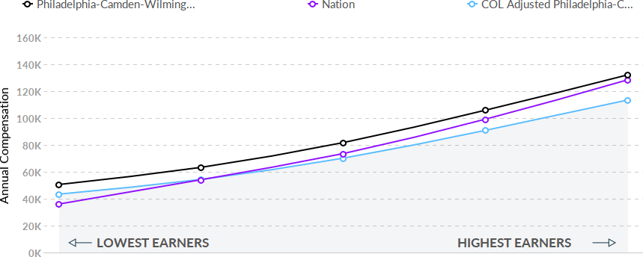

Job Posting Activity

22,507 Unique Job Postings

The number of unique postings for this job from Sep 2016 to Nov 2020.

3965 Employers Competing

All employers in the region who posted for this job from Sep 2016 to Nov 2020.

33 Day Median Duration

Posting duration is 2 days longer than what's typical in the region.

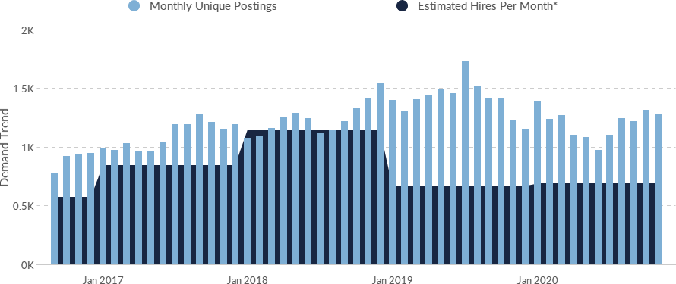

Occupation
Avg Monthly Postings (Sep
2016 - Nov 2020)
Avg Monthly Hires (Sep 2016 - Nov 2020)

Project Management Specialists and Business Operations Specialists, All Other

1,213 820

*A hire is reported by the Quarterly Workforce Indicators when an individual's Social Security Number appears on a company's payroll and was not there the quarter before. Emsi hires are calculated using a combination of Emsi jobs data, information on separation rates from the Bureau of Labor Statistics (BLS), and industry-based hires data from the Census Bureau.

Top Companies | Unique Postings
Anthem, Inc. | 642
Oracle Corporation | 419
Merck & Co., Inc. | 403
JPMorgan Chase & Co. | 377
Comcast Corporation | 350
Deloitte LLP | 350
Accenture PLC | 202
Bank of America Corporation | 194
University of Pennsylvania | 189
Army National Guard | 169

Top Job Titles | Unique Postings
Contract Specialists | 521
Operations Specialists | 387
Business Development Specialists | 338
Credentialing Specialists | 223
Operations Associates | 198
Operations Coordinators | 183
Contracts and Grants Analysts | 170
Contract Analysts | 160
Quality Specialists | 156
Chemical Operations Specialists | 146

Top Hard Skills
Skills | Postings | % of Total Postings | Profiles | % of Total Profiles
Auditing | 3,638 | 16% | 1,415 | 8%
Accounting | 2,146 | 10% | 1,460 | 9%
Business Development | 1,963 | 9% | 1,851 | 11%
Pharmaceuticals | 1,524 | 7% | 1,028 | 6%
Project Management | 1,443 | 6% | 1,906 | 11%
Business Process | 1,373 | 6% | 608 | 4%
Risk Management | 1,287 | 6% | 943 | 6%
Billing | 1,242 | 6% | 1,106 | 7%
Data Analysis | 1,232 | 5% | 1,053 | 6%
Financial Services | 1,225 | 5% | 808 | 5%

Top Common Skills

Skills | Postings | % of Total Postings | Profiles | % of Total Profiles
Communications | 9,843 | 44% | 2,784 | 17%
Operations | 9,404 | 42% | 5,529 | 33%
Management | 9,006 | 40% | 6,867 | 41%
Sales | 5,312 | 24% | 5,328 | 32%
Detail Oriented | 5,029 | 22% | 503 | 3%
Microsoft Excel | 4,966 | 22% | 4,367 | 26%
Problem Solving | 4,512 | 20% | 568 | 3%
Customer Service | 4,402 | 20% | 5,849 | 35%
Leadership | 4,320 | 19% | 5,320 | 32%
Microsoft Office | 3,821 | 17% | 4,139

Demographics

Retirement Risk Is About Average, While Overall Diversity Is Low
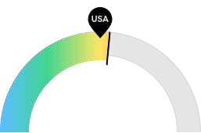
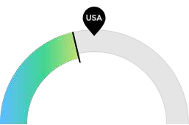
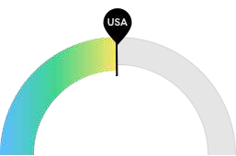

4,951

5,545

10,445

Retiring Soon

Racial Diversity

Gender Diversity

Retirement risk is about average in Philadelphia- Camden-Wilmington, PA-NJ- DE-MD. The national average for an area this size is 4,541* employees 55 or older, while there are 4,951 here.
Racial diversity is low in Philadelphia-Camden- Wilmington, PA-NJ-DE-MD. The national average for an area this size is 6,913* racially diverse employees, while there are 5,545 here.
Gender diversity is about average in Philadelphia- Camden-Wilmington, PA-NJ- DE-MD. The national average for an area this size is 10,556* female employees, while there are 10,445 here.

*National average values are derived by taking the national value for Project Management Specialists and Business Operations Specialists, All Other and scaling it down to account for the difference in overall workforce size between the nation and Philadelphia-Camden-Wilmington, PA-NJ-DE-MD. In other words, the values represent the national average adjusted for region size.

Occupation Age Breakdown
 | % of Jobs | Jobs
⬤ 14-18 | 0.1% | 26
⬤ 19-24 | 4.7% | 857
⬤ 25-34 | 22.8% | 4,135
⬤ 35-44 | 22.5% | 4,068
⬤ 45-54 | 22.5% | 4,075
⬤ 55-64 | 21.1% | 3,824
⬤ 65+ | 6.2% | 1,127

Occupation Race/Ethnicity Breakdown

 |  | % of Jobs | Jobs
⬤ | White | 69.4% | 12,566
⬤ | Black or African American | 15.0% | 2,711
⬤ | Asian | 7.6% | 1,379
⬤ | Hispanic or Latino | 6.4% | 1,151
⬤ | Two or More Races | 1.5% | 280
⬤ | American Indian or Alaska Native | 0.1% | 17
⬤ | Native Hawaiian or Other Pacific Islander | 0.0% | 7

Occupation Gender Breakdown

% of Jobs Jobs

⬤ Males 42.3% 7,666

⬤ Females 57.7% 10,445

National Educational Attainment

% of Jobs

⬤ Less than high school diploma 1.4%

⬤ High school diploma or equivalent 9.7%

⬤ Some college, no degree 16.7%

⬤ Associate's degree 7.7%

⬤ Bachelor's degree 40.5%

⬤ Master's degree 20.2%

⬤ Doctoral or professional degree 3.9%

Occupational Programs

2 Programs

Of the programs that can train for this job, 2 have produced completions in the last 5 years.

126 Completions (2019)

The completions from all regional institutions for all degree types.

1,855 Openings (2019)

The average number of openings for an occupation in the region is 452.

CIP Code | Top Programs Educational Programs Tooltip, click to read | Completions (2019)
52.9999 | Business, Management, Marketing, and Related Support Services, Other | 106
52.0907 | Meeting and Event Planning | 20

Top Schools | Completions (2019)
Widener University | 55
Villanova University | 41
Temple University | 16
Eastern University | 10
Bucks County Community College | 4

PMI (2017). Project Management Job Growth and Talent Gap 2017–2027.

